No. | Task description | Duration (hrs) | Resources | Date completed | Comments
1 | Create and save a new html file using VS code. | 5 minutes | VS code. | 5/5/2026 | I chose VS code over Note Pad ++ because I had already downloaded it for Python coding and it also had more features.
2 | Create/Code menu bar UI (Including colours) for the homepage | 15 minutes | VS code, Onenote resources, Teacher, Link, Brave browser. | 5/11/2026 | I completed step 2 and step 3 together. I first added the div of the titles for the navigation bar and then I added the div for the green bar and put the titles inside. After, I wrote the CSS styling to add small details. Additionally, the search bar had a button added for easier access and better looks and the words in the Search bar were edited to make it look more professional into “Search…”.
2 | Create/code the Titles and search bar for the menu bar in the homepage. | 10 minutes | VS code, Onenote resources, Teacher, Link, link, Brave Browser. | 5/11/2026
3 | Create/ Code the structure for the titles and paragraphs for the homepage and paste placeholder text in it. | 15 minutes | VS code, Link, Link, Resources, Brave Browser. | 5/18/2026 | While doing this step, I realised that I had to add the Avenir Pro font to my titles, so I downloaded the font and used @fontface to define the font. After completing the first page I showed it to my client to review, and he said that the Avenir Pro font looked very nice and he wanted to use it for the paragraphs too, so I implemented that. For
4 | Create a new page for my website. Create a new html document on VS code for the About us page. | 5 minutes | VS Code, Brave Browser. | 5/22/2026 | At first, I was confused to how I would create a new page for my website, but after asking my friend, I realised that I had to create a new document for the new page and link them together.
5 | Copy the code from the menu bar in the homepage and paste it in the About us page. | 1 minutes | VS Code, Brave Browser. | 5/22/2026 | I was able to copy over the code for the menu bar over to my About Us document and edit the divs and CSS slightly to let it fit in. I also had to bold the About us button and un-bold the Home button because the audience is on the About Us page.
6 | Link the About us button in the homepage to the About us screen using code. | 1 minutes | VS Code, Brave Browser, Link. | 5/22/2026 | I did these 2 sections together because they were very easy and required practically 0 time. I just had to paste the link of the two documents into a bracket that I set up earlier.
6 | Link the "Home" button from the About us page to the homepage. | 1 minutes | VS Code, Brave Browser, Link. | 5/22/2026
7 | Code the first title/paragraph in the About Us page (About the author) | 20 minutes | VS Code, Brave Browser. | 5/22/2026 | I was able to do this code successfully easily after doing a little bit CSS formatting and adding the text in a div and editing it a little.
8 | Code (Link) the image of author for the About Us page | 5 minutes | VS code, Brave Browser, High fidelity power point. | 5/22/2026 | While doing this step I had to delete some of the words in the paragraph above the image for better fitting.
9 | Code the second title/paragraph for the About Us page (Our passion) | 30 minutes | VS code, Brave Browser, Link. | 6/1/2026 | This page caused me to have to edit my div tags because I realised that I needed to create 2 flexboxes to format the two paragraphs and titles correctly. This took me some extra time. After finishing my website, I thought that the second page had an empty background, so I asked my client and he said he liked a bright green background so coded a background for the body.
Note: I used brave browser to open my webpage (NOT RESEARCH).

Screenshots of final solution:
Page 1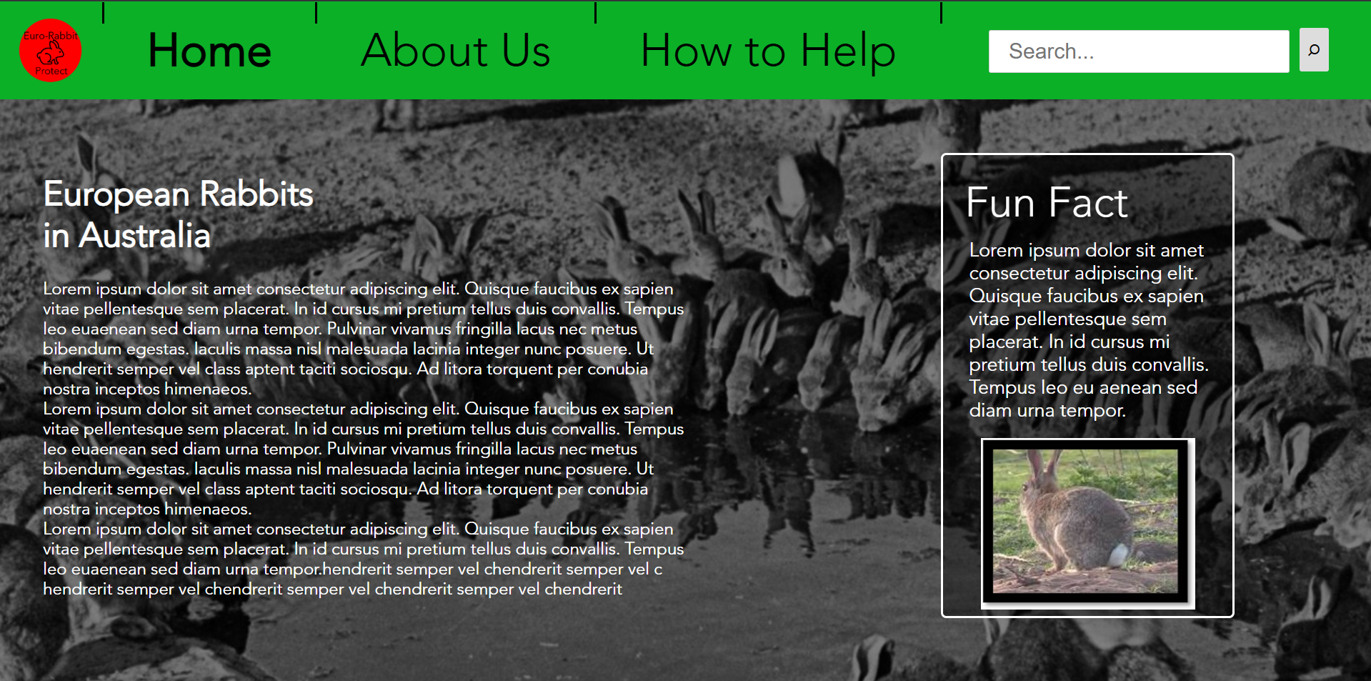Page 2:
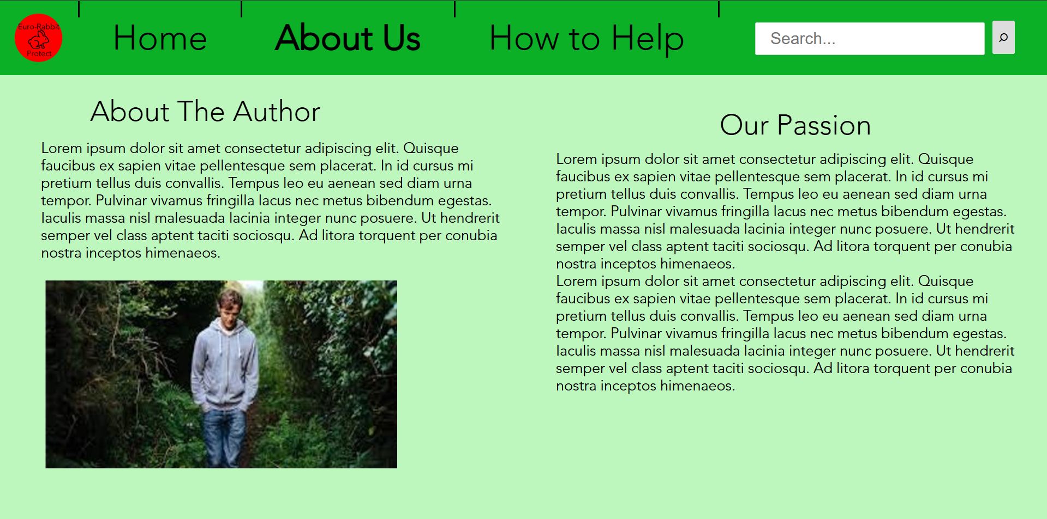

Di: Testing Plan
Success Criteria | Testing Method | Results
SC 1: The website being created must have two pages, including a homepage and an information page which can both be accessed through the navigation menu. | Functionality testing using client- I will observe the client use the website and use the buttons to see if the website is easy to navigate and if it works. | The website worked well and switching pages wasn't difficult or confusing. My client loved the simple layout of the navigation bar because he thought it would be easy to use for all ages (most). Therefore, this criterion has been met.
SC 2: The website must use a minimalistic design with simple fonts and overviewing titles. | Observation testing using client and 2 classmate- The testers will use the website, and they will give me feedback on the design (Whether it is minimalistic or/and simple). Ask them whether the website is minimalistic and if they are able to follow the titles. | My client said that the webpages were very simple and easy to read and understand. He liked the paragraphing and simple titles especially. My two classmates both liked the minimalism and thought the layout was ok and followable by most ages. Therefore, this criterion has been met.
SC 3: The website must include an effective colour scheme that symbolises nature and hope (using colours such as orange), it must also include colours to show how nature has been destroyed such as black and white images. | Observation testing using my client and two classmates- Let them test the website and ask them whether the colour scheme and images give a natural, hopeful or destructive vibe based off the situation. | The testers said the website had a nice colour scheme that made them feel the natural vibe, they also thought it gave the website a better look. The black and white picture also gave them a destroyed vibe which made them feel empathetic for the nature. Additionally, the logo gave a hopeful vibe which helped with the website. Therefore, this criterion has been met.
SC 4: The website must be function properly on different browsers such as edge or chrome, to be more convenient. | Compatibility test using different browsers- I will open my website on multiple different browsers: Chrome and Edge. This will test the compatibility showing better convenience. | My website was compatible with different types of browsers like chrome and edge. But, when on edge, because of the different sizing of screens the reader is able to scroll up and down slightly and the navigation bar is 2 rows
SC 5: The website must include images that are related to the topic to help the audience visualise the context. | Observation testing using my client and 2 classmates- They will use the website and give feedback on the images, whether they have been used well and if they help them read it. | Overall, my testers gave positive results saying that the images worked well especially the black and white image which made them feel the situation better, but one of my classmates thought that the image for the fun fact section was cute and made him like bunnies instead of knowing that they’re invasive species.
SC 6: The information page on the website must showcase the invasiveness of European rabbits to the audience by using small fact boxes which keeps the audience’s attention. (Unable to test the information, but can test the fact box) | Observation testing using client and 2 classmates- Ask them whether they think the fun fact box idea would assist with delivering information more effectively and if they would stay attentive longer because of the section. | 2 out of the 3 testers agreed that the idea would be good because it gives variety on the website and would keep the audience’s attention. The other tester thought that it might distract the reader from the main topic and cause them to focus slightly too much on the fun fact. He suggested that the fun fact should be highly related to the topic because at first I gave an example of what the fun fact could be and it was more of an overall fact about rabbits. Such as, Rabbits are responsible for over $200 million worth of destruction. Therefore, the criterion was met, but the idea for the fun fact box could be changed slightly.
SC 7: The structure of the website must be easy to navigate including a menu, and easy to understand text structure with subtitles and information below. | Observation testing using client and 2 classmates- I will ask the testers to try navigating the website using the navigation bar and ask them to give feedback on the layout of the website and if it were in an easily understandable structure. | The testers said that the website was in an extremely good structure that made good chronological order and was easy to read and follow. The navigation bar was also structured nicely according to them because it started with the Home page up to the Donate page in order. They also liked the left to right simple format with obvious titles/subtitles to follow. Therefore, this criterion was met.
SC 8: The website must have a page that includes information about the client so the audience can understand why my client is doing this supporting them to donate in a donate page. | Observation testing using client and 2 classmates- I will ask the testers to look at the About us webpage and ask them if this idea is good and if it would persuade them to feel empathetic for the client. | The testers said that the About us page was a very good addon to the website overall and it gave them a feeling that showing the audience about the author will let them connect and feel for each other metaphorically. This will increase the chance of a donation etc. Therefore, this criterion has been met.
Dii: Evaluation
My website creation (for my client) was successful and will provide the audience with valuable information about invasive rabbit species and give them a way to support the environment and giving them information about my client to help them connect and feel empathetic. My website includes 2 main pages which are effectively navigable using a navigation bar with working interactive buttons with the about us page persuading the audience to donate and support us (SC1) (SC8). Additionally, my website has a minimalistic, simple design with precise paragraphs with titles/subtitles that are easily readable for most ages (SC2) (SC7). My design also has an effective use of colours from black and white images for environmental destruction giving a destructive and depressing mood to an orange logo and green background to show a hopeful and natural vibe (SC3). The website is compatible with multiple browsers with only a small glitch that shows some text in the navigation bar onto the second row due to screen sizing on ‘edge’ which will allow everyone with a laptop to access (SC4). Furthermore, my website includes various imaging to help the reader visualise the information and to make them feel certain ways using black and white colouring techniques or greenery around the author to show their connection to nature (SC5). The fun fact box also helps keep the audience’s attention and helps the read focused, improving their experience (SC6). Overall, my website has allowed my client to portray his information about invasive rabbit species and influence others positively effectively.
Diii + iv: Recommendations for Future
Throughout the development of my website, I have realised multiple improvements that could be made to benefit the solution for my client, the target audience and any economic costs. In the future, to help improve the website, I will complete the ‘Donate page’ that will provide funds to help pay for the costs of publishing the website and eventually verifying it in the future. To improve the website to benefit my client, I can build the website to make it accessible for people on their phones, this will allow a wider audience range and more benefits and donations. Additionally, to give benefits to the social community we can change the donate page to a merch shop which will still earn money, but it will allow the audience to get something in return which will most likely help earning our money back from publishing the website using a domain which will be about $20 for the first year and $25 for later years (Domain Names | Cheap Domain Names Australia, 2026). More ways to improve, includes creating more pages for more information regarding why the client started this project and his passion. Using these improvements me and my client will be able to continue building on our website and spread information about invasive rabbit species.

References
Domain Names | Cheap Domain Names Australia. (2026). Crazydomains.com.au; Domain Names | Cheap Domain Names Australia. https://www.crazydomains.com.au/domain-names-websites/?channelid=P13C300S570N1B3A40D0E0000V194
W3Schools. (2022a). CSS Tutorial. W3schools.com. https://www.w3schools.com/css/default.asp
W3Schools. (2022b). HTML Tutorial. W3schools.com; Refsnes Data. https://www.w3schools.com/html/default.asp

